🎤
THE ALL NEW BLUES & SOUL REVUE – TECHNICAL RIDER

(11-Piece Band Version – with 8-Piece Notes Included)

1. CONTACT & ADVANCE

Production Contact: Dave Wiggins
Role: Band Leader / Production Advance
Email / Phone: Office@BigWigProductions.co.uk Tel 07766 312374
Band Configurations: 11-piece (full) or 8-piece (reduced)

2. STAGE OVERVIEW

Full 11-Piece Line-Up
- Lead Vocals: Dave Wiggins
- Lead Vocals 2: Colin Smith or Christopher Till
- Backing Vocals:
  - Option A: Danni Bentley + Amy Leeder-Dellbridge
  - Option B: Pritee Almeida + 1 Guest BV
- Brass Section:
  - Tenor Sax – Liz Mitchell
  - Trumpet – John Moakes
  - Trombone – Reuben Alldridge
- Band:
  - Drums – Mike Barnes
  - Bass – Richard Spooner
  - Guitar – Daniel Collins
  - Keyboards – Alex Poole

8-Piece Line-Up
- Remove Trombone
- Remove both Backing Vocalists
- Everything else remains identical

3. INPUT LIST – FULL BAND
CLIENT / TECHNICAL TEAM ARE REQUESTED TO PROVIDE ALL WIRELESS / WIRED MICS WHEREVER POSSIBLE - IN THE EVENT THAT THEY CANNOT DO SO, OUR OWN EQUIPMENT IS LISTED BELOW - PLEASE DISCUSS THIS WITH US PRIOR TO THE GIG.
Vocals
- Dave – Wireless HH (830–866 MHz) or venue wireless, STRAIGHT MIC STAND (Not a Boom)
- Colin/Chris – Wireless HH (M-Live B.Beat feeds also required) STRAIGHT MIC STAND (not a BOOM)
- BV1 – Wireless (Danni/Amy/Pritee) or SM58
- BV2 – Wireless (Danni/Amy/Guest) or SM58

Brass
- Tenor Sax – CloudVocal system → XLR line out
- Trumpet – SM57 on stand
- Trombone – SM57 on stand

Backline
- Kick
- Snare
- Hats
- Rack
- Floor
- Overhead L (optional)
- Overhead R (optional)
- Bass – DI out from Richard’s amp
- Guitar – SM57 on guitar cab
- Keys – Mono line out (XLR or Jack). Stereo only if venue supplies DI box.
- B.Beat (Colin): 2 line outputs if needed

4. MONITORING REQUIREMENTS

General Notes
- If IEMs available:
  - Dave, Colin, Chris, Danni, Amy, Pritee all use them
- If wedges only:
  - Dave, Colin and Chris require wide coverage across front of stage
- Audience mics preferred when running full IEM setup so vocalists can hear the crowd
- If only one brass mix is available, Liz (no trumpet in mix) & John (likes trumpet in mix) will compromise between them.

INDIVIDUAL MONITOR MIXES

Dave Wiggins – Lead Vocals
- Primary: Dave
- Secondary: Colin or Chris
- BV’s
- Keys
- Bass
- Kick
- (Wedges + IEM preferred)

Colin Smith – Lead Vocals 2
- Primary: Colin
- Secondary: Dave
- BV’s
- Keys
- Bass
- Kick
- Uses HH Sennheiser Mic / IEM (his own is preferred) + wedge mox
- M-Live B.Beat – requires up to 6 line-level outputs if used

Christopher Till – Lead Vocals 2
- Wedge only
- Wants to hear:
  - Himself, Dave, Keys, Bass, BV’s

Pritee Almeida – Backing Vocals
- Prefers IEMs
- Own EW400 wireless mic available
- Monitor mix:
  - BV’s loud (hers slightly higher)
  - Lead vocals slightly behind
  - Bass, Keys, Guitar at low but audible levels
  - No horns

Danni Bentley – Backing Vocals
- Prefers IEMs
- Has Shure GLXD24+/B87A
- Has Shure PSM300 + 4x P3RA packs
- Mix:
  - BV’s high
  - Lead vocals slightly behind
  - Bass, Guitar, Keys even
  - Small amount of Brass
  - Reverb preferred

Amy Leeder-Dellbridge – Backing Vocals
- Similar to Danni
- Has wireless mic (spec TBC)
- Mix similar:
  - BV’s high
  - Lead vocals slightly behind
  - Keys/Bass/Guitar even
  - Small amount of Brass
  - Reverb preferred

Liz Mitchell – Tenor Sax
- CloudVocal → XLR
- Monitor mix:
  - Sax high
  - Kick up
  - No Guitar / No Trumpet
  - FOH-style balance otherwise
- Warning: CloudVocal auto-frequency hopping may be restricted at festivals

John Moakes – Trumpet
- SM57 on stand
- Monitor mix:
  - Brass prominent
  - Kick up
  - (John likes trumpet in his foldback)

Reuben Alldridge – Trombone
- SM57 on stand
- Prefers entire brass section strong in monitor
- When 3-piece brass present:
  - Prioritise all brass over other instruments

Mike Barnes – Drums
- FOH-style mix
- Kick + Bass guitar boosted
- Prefers wedge but happy with IEM
- Brings own IEMs and small mixer
- 5-piece kit
- Can provide own mic set (or venue may supply)

Richard Spooner – Bass
- DI from own amp to FOH
- Wedge mix:
  - Bass dominant
  - Kick prominent
  - Rest of band even

Daniel Collins – Guitar
- SM57 on Fender valve amp
- Requires 13A mains for amp + pedalboard
- Mix:
  - Guitar prominent
  - Rest of band even

Alex Poole – Keyboards
- XLR or Jack line out (mono)
- Stereo only if DI box provided
- Wired IEMs if needed
- Mix:
  - Keys primary
  - Rest of band balanced

5. WIRELESS & FREQUENCY NOTES

Dave Wiggins / Christopher Till
- Wireless operates 830–866 MHz

Danni Bentley
- Shure GLXD24+ (2.4 GHz & 5.8 GHz)
- Shure PSM300 & P3RA (K3E band: 606–630 MHz)

Amy Leeder-Dellbridge
- Wireless mic – frequency TBC

Pritee Almeida
- Sennheiser EW400 – GB (606–648 MHz)

Liz Mitchell (CloudVocal)
- 2.4GHz global ISM, smart automatic frequency hopping → can cause issues at large RF-controlled festivals
Band IEM system
- CAD Audio GLXIEM4, 902 – 928MhZ

6. POWER REQUIREMENTS
- Guitar Amp – 13A
- Pedalboards – 13A
- Keys – 13A
- B.Beat – 13A
- CloudVocal – 13A
- IEM Rack – 13A
Standard UK backline power acceptable.

7. STAGE PLOT

Attached below as PDF for 11 / 8 piece setups respectively
- 11-Piece configuration
- 8-Piece configuration
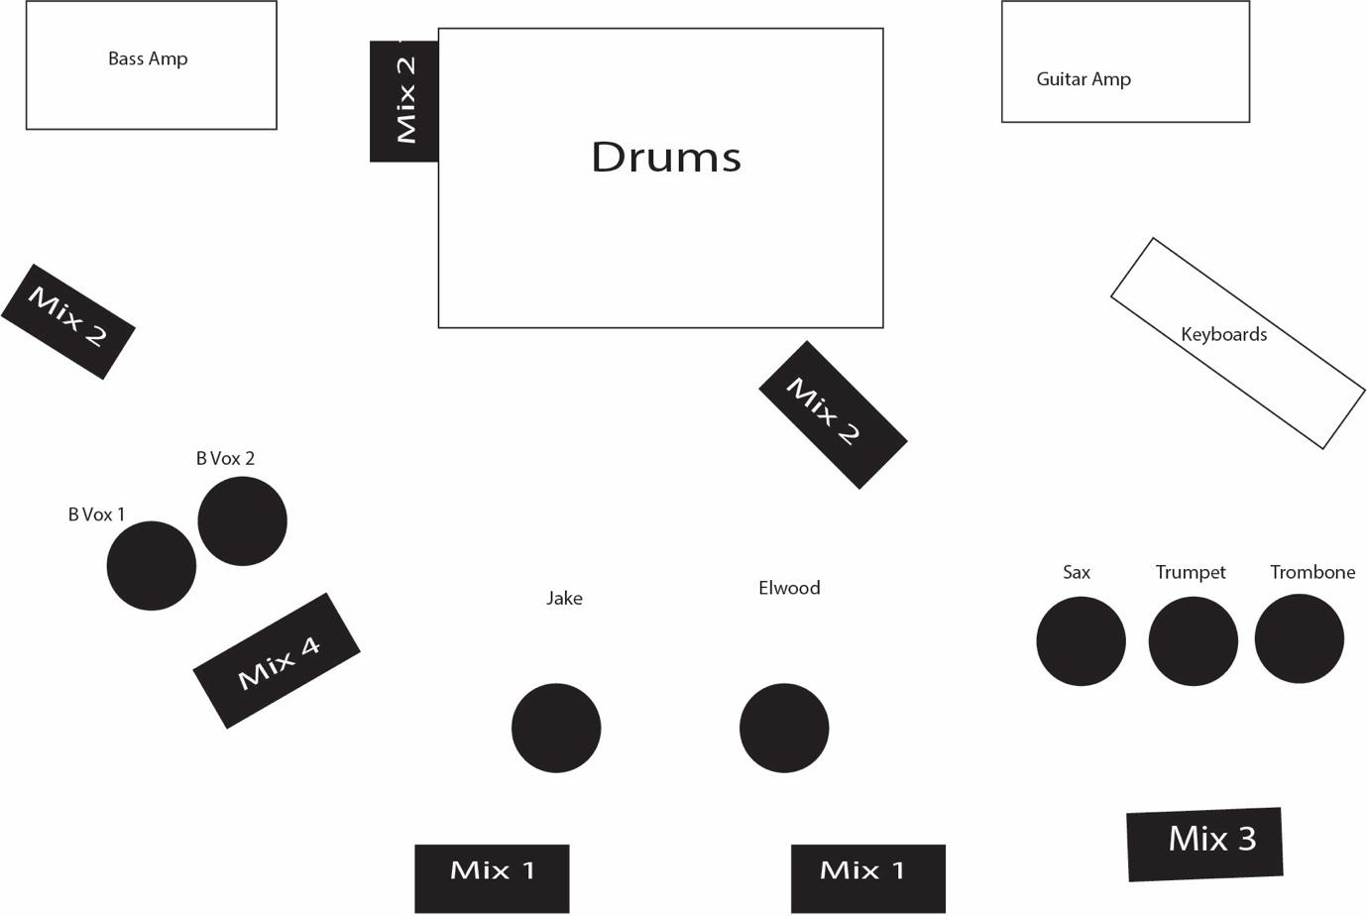

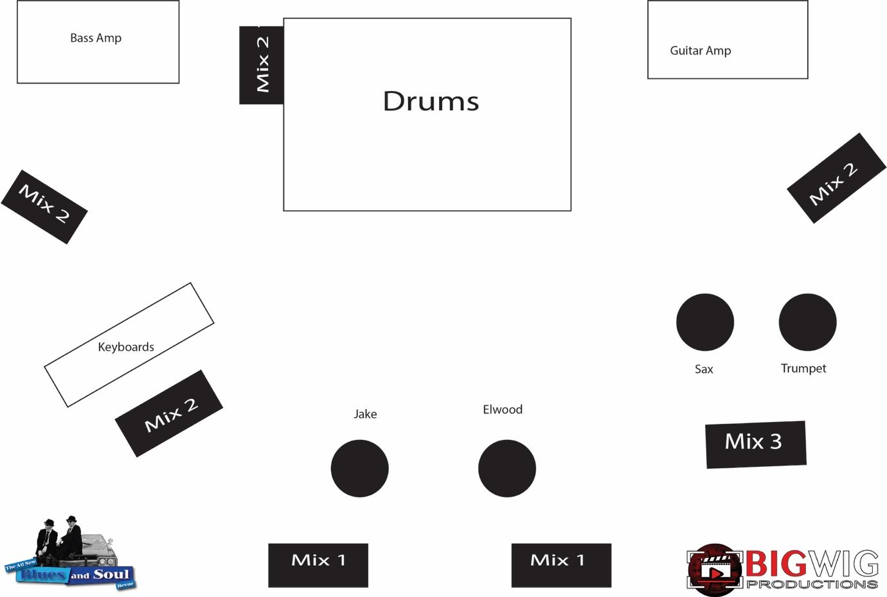
8. GENERAL NOTES
- Band prefers a wide, open front line for movement where possible. Both lead vocalists ‘work the floor’ and will roam into the audience with radio mics.
- Audience ambient crowd mics appreciated for full-IEM setups
- Split snake ideal to allow personal mixes where possible
- Venue to ensure RF compatibility and interference-free operation
- Venue to provide radio mics where possible.

